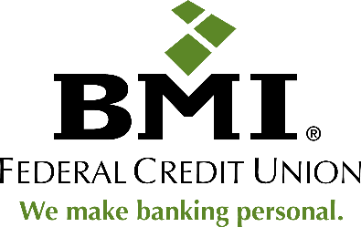

BMI Federal Credit Union
6165 Emerald Parkway
Dublin, Ohio 43016

BMI Federal Credit Union Hosted Scholarship Golf Open Benefitting Folds of Honor
Westerville, Ohio (June 13, 2023) – BMI Federal Credit Union hosted their annual scholarship golf open benefitting Folds of Honor at The Lakes Golf and Country Club on June 12, 2023. Every year, BMI Federal Credit Union uses the money raised from the golf open to put toward a scholarship fund for spouses and children of America’s fallen and disabled service members. Through all the contributions this year, BMI Federal Credit Union raised over $40,000 to support scholarships for families of disabled or fallen soldiers in Ohio. In total, the BMI Federal Credit Union Scholarship Golf Open has raised over $320,321 in scholarship funds since it began in 2014.
About Folds of Honor
Since 2007, Folds of Honor has carried forth this singular, noble mission to provide educational scholarships to spouses and children of America’s fallen and disabled service members. Their motto says it best: Honor their Sacrifice - Educate their Legacy. In the 2022 – 2023 academic school year, in the Central Ohio region, Folds of Honor awarded 120 Educational Scholarships with a total Educational Impact of $452,000. All of the proceeds raised today from the BMI Federal Credit Union Golf Open will help to cover the 49 Educational Scholarship recipients located in the counties in BMI FCU field of membership.
About BMI Federal Credit Union
BMI Federal Credit Union is an award-wining financial institution in Central Ohio, delivering superior member service and competitive financial products. In addition to exceptional banking services, the Credit Union promotes financial wellness throughout the community with an award-winning Financial Education Program, charitable giving efforts, and credit union advocacy.
BMI Federal Credit Union has been recognized by the Columbus Dispatch for the 2018, 2019, 2020, 2021, and 2022 CBUS Top Picks, The Charles B. Jenkins Legacy Award winner in 2021, a Best Employer in Ohio for thirteen consecutive years by Crain’s Cleveland Business and Best Companies Group, and the 2021 CUNA Diamond Award winner for Crisis Management for their response to the COVID-19 pandemic. For more information about BMI Federal Credit Union visit www.bmifcu.org. Federally insured by NCUA. Equal Housing Lender. NMLS ID: 410831.
Press contact:
Carolyn Hucek
Vice President of Marketing
BMI Federal Credit Union
c_hucek@bmifcu.org
614.707.4120

